In exploring the data available we investigated statistics at the state level to determine how each resort fit into a larger background of features and competition. PCA analysis determined that while each state had a fairly unique set of features as they relate to ski resorts, they were each similar enough to compare them all on equal footing when determining a pricing model. As for statistics at the resort level, we derived some intuitive figures for each resort in order to glean characteristics that might show stronger correlations with ticket price. A few such features were the number of “fast quad” lifts available, total number of runs, and the total night skiing acreage. This last one seemed to be of some particular importance, as the ratio of night skiing acreage to total acreage also correlated with the number of resorts per capita by state. This was an important bread crumb; this seemed to indicate that in the face of more stifling competition resorts will compete by increasing night skiing availability.

We began building and training a model to point us to a competitive price for “Big Mountain”. A weather-person who predicts cloudy skies every single day in Seattle will be right more often than not, but this is largely a useless prediction in a place as dreary as Washington. To avoid making a model that stays in this same suit, we endeavoured to make sure our pricing model would predict a number that was better than the simple average of all ski resorts combined. Which is to say, when we test a model it should perform substantially better than one which simply spits out a blanket average. Testing a model is performed by feeding it part of the data, then seeing how well it predicts prices for the rest. Two different types of models were tried, tested and compared. They seemed to agree well on their predictions, but the clear favorite between the two was our “random forest” model, which predicted prices almost a dollar closer than the other and did so with less jitter.  
  
 The “random forest” model (as well as the other model considered) flagged four areas of heightened importance:

\*number of “fast quad” lifts

\*total number of runs

\*acreage which could be covered with artificial snow

\*vertical drop of the terrain

While many factors were considered, these were shown to most greatly affect ticket price. “Big Mountain” performed well in these areas compared to market averages. Based on our model, Big Mountain’s weekend ticket price should be about $95.87. The model is to be taken with a small grain of salt of about $10.39 in either direction. The new calculated price is outside of the $10.39 “wiggle room” of the current price of $81, so an increase in price is well justified. Furthermore, poking and prodding at the numbers for “Big Mountain” revealed features that would most greatly increase ticket prices and which features could be eliminated without substantial detriment. Increasing vertical drop by adding another run would increase ticket price by $1.99. Doing the previous action in addition to adding two acres of artificial snow coverage would have no further effect--a small amount of new snowmaking would not benefit the resort. Similarly, increasing the longest run at the resort by .2 miles had no effect in ticket value and is therefore not a warranted action. The effect of closing runs at the resort was interesting, in that the effect of closures followed a stair-step pattern: 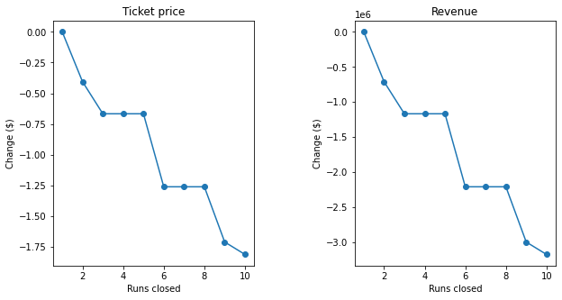

One dropped run does not decrease ticket value, but two or three dropped runs does. However, once we’ve reached three dropped runs, two more could be dropped without any further effect. A similar scenario is presented when considering even more dropped runs. In conclusion, an increase in ticket price is well justified for “Big Mountain”, as well as the dropping of one of its runs. Further dropped runs can be implemented if the maintenance costs of those runs exceeds the resulting loss of revenue.